def tokenize_text(text):

# Split the text by spaces

tokens = []

for word in text.split():

# Remove leading and trailing punctuation

clean_word = word.strip(",.?!:;'\"()[]{}")

if clean_word: # Avoid adding empty strings

tokens.append(clean_word)

return tokens

sample_inputs = [ "Zoro is a swordman."

, "He loves war.",

"His favourite sword style is three sword style."]

for input_text in sample_inputs:

print("Input Text:", input_text)

tokens = tokenize_text(input_text)

print("Tokens:", tokens)

print("---------------")

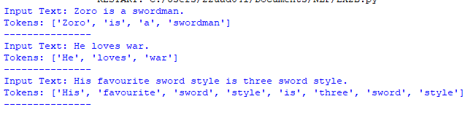

import nltk

def tokenize_text(text):

tokens = nltk.word_tokenize(text)

return tokens

def split_sentences(text):

sentences = nltk.sent_tokenize(text)

return sentences

sample_inputs = ["Zoro is a swordman.

He loves war.

His favourite sword style is three sword style."]

for input_text in sample_inputs:

print("Input Text:", input_text)

sentences = split_sentences(input_text)

print("Sentences:", sentences)

for sentence in sentences:

tokens = tokenize_text(sentence)

print("Tokens for sentence:", sentence)

print("Tokens:", tokens)

print("---------------")

